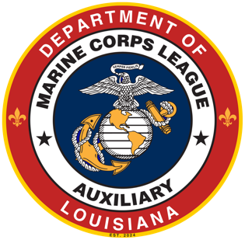
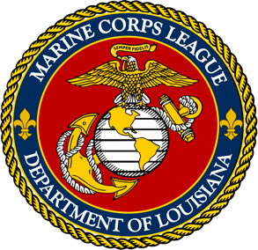
2026 Department of Louisiana Convention
June 5-6, 2026

HOMEWOOD SUITES
Lafayette, LA

Marine Corps League Auxiliary Agenda
**Schedule subject to Change**
Friday, June 5th
1:00 - 5:00 Registration MCL/MCLA/MODD and Ship Store open
1:00 - 10:00 Hospitality Room open
1:30 - 3:30 Team Building Project - All Women Invited
3:30 - 5:00 Flea Scratch
6:45 - til Supper - provided by Host Detachment
Saturday, June 6th
8:00 - 1:00 Registration and Ship Store open
8:00 - 5:00 Hospitality Room open
9:00 - 9:20 Opening Ceremonies/Joint Session - Commandants Remarks
9:20 - 9:40 Memorial Service and Chaplain of Four Chaplains
9:40 - 9:45 Ronnie Broussard, MCL SE Division Vice
9:45 - 9:50 Becky Marcel, MCLA SE Division Vice

9:50 - 10:00 PNC Johnny Baker
10:00 - 10:15 Guest Speaker - Charles McGinley VA Secretary / Close Joint Session
10:15 - 10:30 Recess
10:30 - 12:00 MCLA Business Meeting
12:00 - 1:00 Lunch - Provided by Host Detachment
1:00 - 4:00 MCLA Business Meeting - Election of Officers
6:00 - til MCL & MCLA Department Officer Installation & Awards Banquet

