Marine Corps League
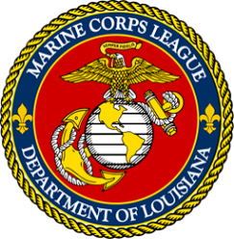 | 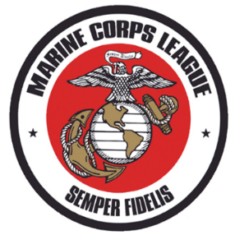 | 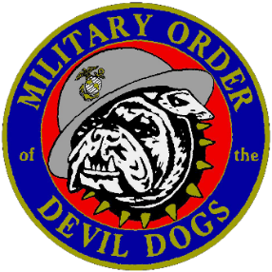 | 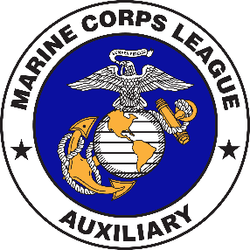
Department of Louisiana
Meeting Agenda (TENTATIVELY)
FRIDAY, JUNE 5TH, 2026
1300 - 1700 REGISTRATION AND SHIP STORE
1300 - 2200 HOSPITALITY ROOM
1430 - 1500 BY-LAWS & ADMIN PROCEDURES COMMITTEE
1500 - 1530 RULES COMMITTEE
1600 - 1645 COMMANDANTS COUNCIL---DETACHMENTS
1700 - 1730 MODD PROMOTIONAL ORIENTATION
1645 – 1730 PDC COUNSEL & FINANCE
1730 - 1830 MODD GRAND GROWL ( PACK)
1845 - TILL FOOD PROVIDED BY HOST DETACHMENTS ( JAMBALAYA/REFRESHMENTS & MUSIC)
SATURDAY, JUNE 6TH, 2026
0800 - 1000 REGISTRATION AND SHIP STORE
0900 - 0920 OPENING CEREMONIES /JOINT SESSION – COMMANDANTS REMARKS
0920 – 0940 MEMORIAL SERVICE / CHAPLAIN of 4 CHAPLAINS
0940 - 0945 RONNIE BROUSSARD, SE DIVISION VICE
0945 – 0950 BECKY MARCEL, SE DIVISION MCL AUXILIARY/ANGIE NEAL MADAM PRESIDENT DEPT OF LA
0950 - 1000 PNC JOHNNY BAKER SPEAKS
1000- 1015 GUEST SPEAKER CHARLES MCGINLEY VA SECRETARY/ CLOSING REMARKS /RECESS
1030 - 1200 MCL BUSINESS MEETING/ LADIES BUSINESS MTG
1200 - 1300 LUNCH (PROVIDED BY HOST DETACHMENTS)
1300 - 1400 BYLAWS APPROVAL & ELECTION OF OFFICERS / CLOSING CEREMONIES
1415 - 1530 AWARD SELECTION COMMITTEE - DEPARTMENT MOY & AMOY ( MEET IN ROOM)
1530 - 1800 BREAK TO PREPARE FOR BANQUET
1800- TILL DEPARTMENT BANQUET & OFFICER INSTALLATION/AUX INSTALLATION

